InterTrade Ireland publishes special Covid-19 business portal
By
News Highland
-
April 15, 2020

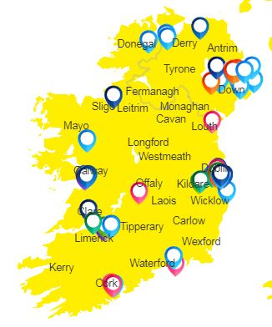
Companies and organisations aiming to help healthcare responses to the Covid-19 crisis can now collaborate via a new online platform.
InterTradeIreland and TechIreland have set up the portal, which allows people see very quickly who is involved in similar projects such as themselves both inside and outside their area.
This in turn means they can discuss collaborations online and make sure they speedily and efficiently meet pressing public need.
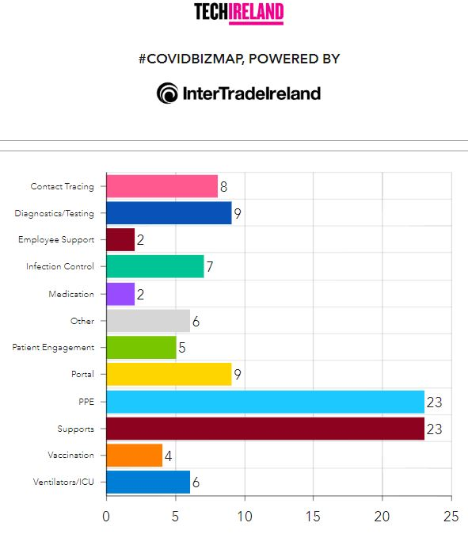
John O'Dea is Chief Executive of TechIreland. He says this is all about cooperation..........

Audio Player
00:00
00:00
Use Up/Down Arrow keys to increase or decrease volume.

Release in full -
Companies aiming to help healthcare responses to the Covid-19 crisis can now collaborate via a new online platform.

Spearheaded by InterTradeIreland and TechIreland, the cross-border platform allows businesses to see quickly, in and beyond their region, who they can work with to combat the many supply chain and manufacturing challenges generated by the pandemic and meet pressing public need.
Presented as an interactive map, it will initially focus on healthcare innovation supports – but will soon expand to include broader economic and societal responses to coronavirus. It will also contain links to public tenders.

Already more than 100 businesses and supports are featured on the map. It highlights more than 10 key categories including PPE, contact tracing, ventilators, among others.

Aidan Gough, InterTradeIreland Designated Officer, said: “Time is of the essence in the response to Covid-19, which is why we have worked swiftly with our partners TechIreland to develop this one-stop-shop for buyers and sellers. It gives firms involved in developing healthcare responses the ability, at a glance, to find other companies they can work with in terms of securing expertise or supply chain input.”

At the moment the map reflects ten different groups developing contact tracing apps, eight companies innovating infection control solutions, 20 firms and groups producing PPE and over 23 other financial and wider supports. This is merely the beginning, as the database grows there will be many more.

Highlighting these companies and groups will enable them to move faster by allowing them to collaborate, learn from each other and avail of the financial and wider supports coming from economic and industrial development agencies.

TechIreland, Chief Executive, John O’Dea, said: “One of the positive responses which will help see us through this crisis will be the solutions that come from products and innovations that are being developed by the business community.

“As a result of the avalanche of information around Covid-19, and because of social distancing, it’s difficult for firms to know what other companies are doing, how they are innovating and if there are opportunities to co-operate. In a fast-moving crisis, finding a potential partner or a customer, or identifying grants and funds can be time-consuming – but critical. This platform has been developed to address those challenges.”

TechIreland has contacted its partner organisations and up to 400 health-tech companies on its database to source information on solutions being built to fight the pandemic. The platform will be constantly revised and updated with new information.

To be featured on the Covid-19 Innovation Reponses Map, or if you are aware of projects that should be included, email John@TechIreland.org

